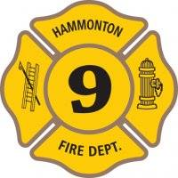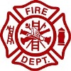
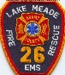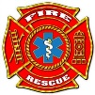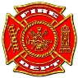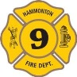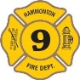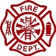
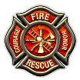
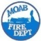
STATE PARK RANGER STATE PARK RANGER STATE PARK RANGER STATE PARK RANGER STATE PARK RANGER STATE PARK RANGER
STATE PARK RANGER STATE PARK RANGER SQUAD SQUAD SQUAD 2 2 2
BATTALION CHIEF 3 BATTALION CHIEF 3 BATTALION CHIEF 3 CHARLOTTE FIRE DEPT. CHARLOTTE FIRE DEPT. CHARLOTTE FIRE DEPT. FIRE DEPARTMENT FIRE DEPARTMENT
FORT MEADE FORT MEADE FORT MEADE ENGINE 1 ENGINE 1 E6-1 E6-1 BATALLION CHIEF BATALLION CHIEF BATALLION CHIEF BATALLION CHIEF BATALLION CHIEF
FIRE DEPARTMENT FIRE DEPARTMENT FIRE DEPARTMENT FIRE DEPARTMENT FIRE DEPT. FIRE DEPT. FIRE DEPT. FIRE DEPT. FIRE CHIEF CHIEF CHIEF CHIEF FIRE CHIEF
. FIRE DEPARTMENT FIRE DEPARTMENT FIRE DEPARTMENT FIRE DEPARTMENT FIRE DEPT. FIRE DEPT. FIRE DEPT. FIRE DEPT. F

MEDECIN SAPEURS-POMPIERS MEDECIN SAPEURS-POMPIERS MEDECIN SAPEURS-POMPIERS MEDECIN SAPEURS-POMPIERS MEDECIN SAPEURS-POMPIERS MEDECIN SAPEURS-POMPIERS .

KEEP BACK 200 FT KEEP BACK 200 FT KEEP BACK 200 FT KEEP BACK 200 FT KEEP BACK 200 FT KEEP BACK 200 FT KEEP BACK 200 FT KEEP BACK 200 FT

MEDECIN POMPIERS MEDECIN POMPIERS MEDECIN POMPIERS MEDECIN POMPIERS MEDECIN POMPIERS MEDECIN POMPIERS MEDECIN POMPIERS MEDECIN POMPIERS ;
C900 C900 C900 C900 C900 C751 C751 C 751 C751 C 751 C780 C780 C780 C780 C780 D512 D512 D512 D512 D512
SQUAD 2
CCF4 CCF2 CAYLA SINCE SINCE SINCE SINCE SINCE 1887 1887 1887 1887 1887

RESCUE 26
FIRE DEPARTMENT CO. 26 CO. 26 26

RESCUE 26
FIRE DEPARTMENT FIRE DEPT. FIRE DEPT. FIRE DEPT. FIRE DEPT. FIRE DEPT.
HAMMONTON
CHARLOTTE
CHARLOTTE
CHARLOTTE
CHARLOTTE
CHARLOTTE
HAMMONTON

FORT WORTH FIRE FORT WORTH FIRE SQUAD 2 SQUAD 2

RESCUE 26

LAKE MEAD

FIRE & RESCUE

LAKE MEAD

FIRE & RESCUE

LAKE MEAD

FIRE & RESCUE

